Bring Your Own Device… for READING!
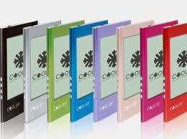
Nooks, iPads, & Kindles have become common tools used for reading used in many homes across our country. Does your child use an e-reader at home? If the answer is yes, your child now has the opportunity to bring this tool to school.
Please fill out the portion below and return it with your child IF your child has permission to bring an e-reader or listening device to school to use during Reading Workshop and other specified reading times.
---------------------------------------------------------------------------------------------------
Expectations:
- The E-Reader/listening device may only be used in the classroom during specified reading times, and may only be used for reading purposes.
- Your child will be responsible for bringing it to school and taking it home each night to keep the item charged and in his/her possession.
- The school is not responsible for replacing the item if it is broken, lost, or damaged on school property.
- Misuse will result in your child losing the privilege of using the tool at school.

I, ________________________, understand the expectations listed above and have discussed them with my child.
Parent Signature: ______________________________
Student Signature: ______________________________
Date: ______________________________

